Website Planning & Documentation
INTRODUCTION
Kappa Sport Store is a business that specializes in selling genuine Kappa sports clothing and sports equipment. The store provides a variety of products designed for people who participate in sports, exercise regularly, or simply enjoy wearing comfortable and stylish sportswear. These products include sports apparel, shoes, and accessories that support both performance and everyday activities.
The purpose of Kappa Sport Store is to meet the needs of customers by offering quality products that are reliable, durable, and fashionable. The store is committed to giving good customer service and ensuring that customers are satisfied with the items they purchase. By supplying well-known sports brands such as Kappa, the business aims to attract customers and build trust within the community.
This documentation explains the background and daily operations of Kappa Sport Store. It outlines the products and services offered, the goals of the business, and how the store plans to operate successfully in the sports retail market.

- WEBSITE SPECIFICATION
- OBJECTIVE
The main objective of the website is to create an online presence for a sports retail business. The website is designed to provide information about sports products, promote the brand, and allow customers to easily learn about available items.
- GOALS
The website is developed with the following goals:
- To display sports products in an organized and attractive way
- To promote the business and increase brand awareness
- To provide clear and accessible information to customers
- To create an easy communication channel through a contact form
- To improve customer experience through a simple and user-friendly interface
These goals help ensure the website supports both the business and its customers effectively.
- TARGET AUDIENCE
The website is designed for a wide range of users who are interested in sports.

Demographics:
- Age group: 15 – 45 years
- Gender: All genders
- Location: Botswana and other regions
- Interests: Sports, fitness, football, training equipment

Technical aptitude:
The target users are expected to have basic digital skills such as:
- Using smartphones or computers
- Browsing websites
- Clicking links and navigating menus
- Filling out simple online forms
Because of this, the website will be designed to be simple, clear, and easy to use.
- TYPE OF WEBSITE
The Elite Sports Store website is a business and e-commerce style informational website.
It focuses on:
- Displaying sports products
- Providing business information
- Allowing customer interaction
The website includes the following pages:
- Home Page
- About Page
- Products Page
- Gallery Page
- Contact Page
All pages are connected through a navigation menu to ensure smooth browsing.

- INFORMATION DESIGN & TEXANOMY
The website content is organized in a clear structure to make navigation simple for users.
- WEB STRUCTRE (Site Map)
Home
│
├── About
│
├── Products
│
├── Gallery
│
└── Contact

HOME

ABOUT
CONTACT
GALLERY
PRODUCTS

Home page:
The Home Page is the main entry point of the website. It provides a brief introduction to Elite Sports Store and gives users an overview of what the business offers.
This page includes a navigation menu at the top, allowing users to move to other sections of the website easily. It also contains a hero section with a headline and short message to attract attention. Below that, there is introductory content explaining the purpose of the store, along with an image to make the page more visually appealing.
The Home Page is designed to create a strong first impression and guide users to explore other pages.

About page:
The About Page provides background information about the business. It explains what Elite Sports Store is, what it offers, and its purpose.
This page helps users understand the identity of the business and builds trust by clearly describing its mission and focus on providing quality sports equipment. It also includes an image to support the content visually.
The layout is simple and easy to read, ensuring that users can quickly understand the information presented.

Product page:
The Products Page displays the different sports items available in the store. These include products such as footballs, boots, and jerseys.
Each product is shown with an image and a short description. The products are arranged in a structured layout to make browsing easy and organized.
This page is important because it showcases what the business offers and helps users see the range of available items.

Gallery page:
The Gallery Page contains images related to sports activities, products, and events. It is designed to make the website more engaging and visually interesting.
The images are displayed in a grid-like format, allowing users to view multiple pictures at once. This page helps to enhance the overall appearance of the website and provides a visual representation of the sports environment.
Contact page:
The Contact Page allows users to communicate with the business. It includes a form where users can enter their name, email address, and message.
JavaScript is used on this page to validate the form, ensuring that users provide the required information before submitting. This improves the functionality and reliability of the website.
The page is designed to be simple and user-friendly, making it easy for visitors to send inquiries or feedback.

Each page is linked through a navigation bar placed at the top of the website.
Users can move between pages easily without confusion.
The design follows the three-click rule, meaning users can find any important information within three clicks.

- NAVIGATION FLOW (Storyboard Explanation)
- Users start on the Home Page
- From there they can:
  - Learn about the store (About)
  - View products (Products)
  - See images (Gallery)
  - Contact the business (Contact)
This flow ensures a smooth and logical user experience.

- TECHNICAL BRIEF
The website is developed using the following technologies and tools:
- TECHNOLOGIES TO USE
HTML5
This is a hypertext markup language 5 and i will use it to structure the content of the website pages.
CSS3
This is a cascading styles sheet 3 I will use it to design the layout, colours, and overall appearance of the website.
JavaScript
Will be used to add interactivity, especially for validating the contact form.

- TOOLS TO USE
GitHub
I will use it for storing the project files and managing versions.
GitHub Pages
I will use it to host and publish the website online.
Image Editing Software (e.g., GIMP)
I will use it to create and edit images such as logos and product pictures.

PAGE TEMPLATE
WIRE FRAME

HOME PAGE

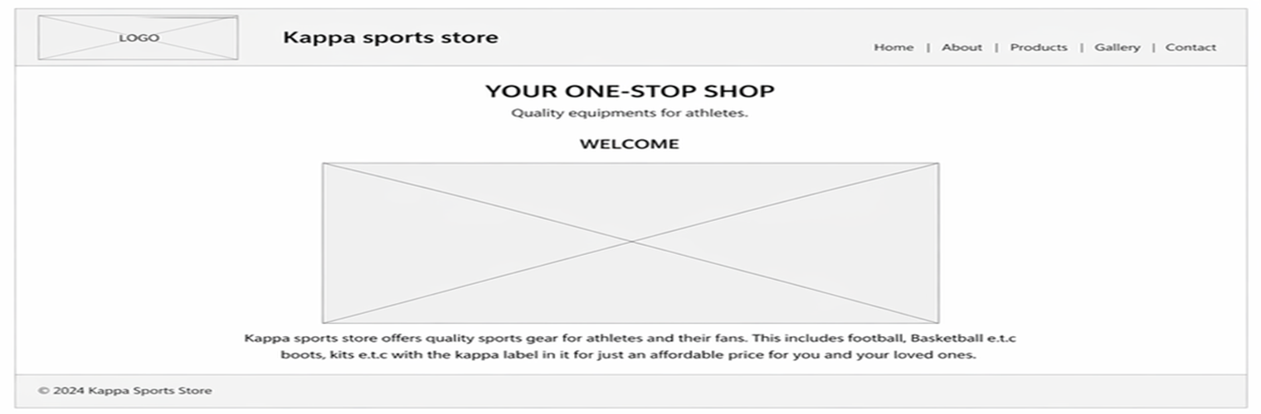
IMAGE

ABOUT PAGE
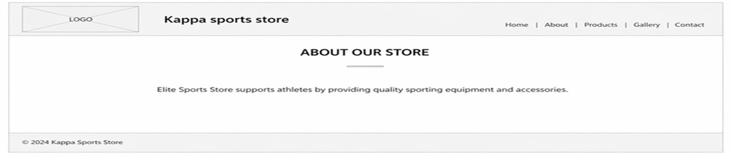

PRODUCT PAGE

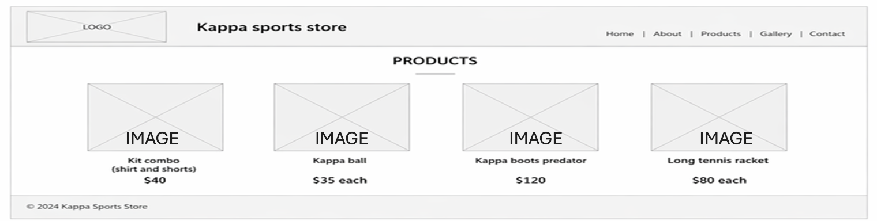

GALLERY PAGE

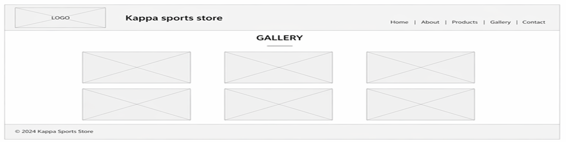

CONTACT PAGE

